EVENT REPORT
EVENT: TRIBUTE TO INTERNET MARTYR-AARON SWARTZ
"AARON DAY"
Hosted by: KLU GNU/Linux Users Group and Swecha
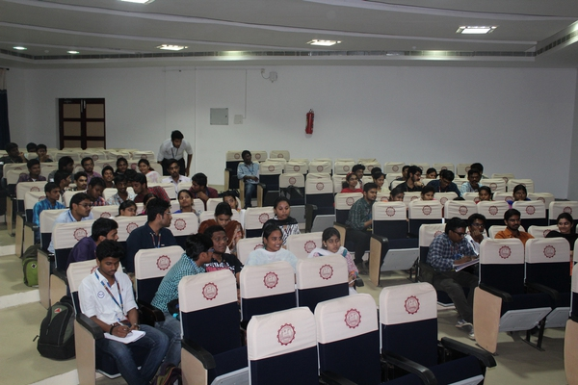
Who was there?
- 16 Volunteers
- 60 students
When was the event scheduled?
- 8th Nov 2016, Jasmine Hall, KL UNIVERSITY
- Timings: 2pm to 8pm
Event Schedule:
- 2:00pm to 2:30pm: Introduction to KLUG
People who inspired KLUG
Previous activities of KLUG
- 2:30pm to 3:00pm: Quiz on FOSS logos
- 3:00pm to 4:00pm: Webinar on intro to open access by Srikar Gutam from
Open Access India
- 4:00pm to 4:30pm: Debate on "Patents and Copy rights"
- 4:45pm to 5:10pm: Talk by Pramod , Executive member at Swecha
- 5:10pm to 7:00pm: Movie Screening "Internet's own boy"
- 7:00pm to 7:30pm: Discussion Post Screening
- 7:30pm to 8:00pm: Quiz results
Future Activities by KLUG
Participant reviews
Vote of Thanks
Event Focus
- To let students know about Free and Open Source Software available.
- What is Open access and its need
- Consequences due to patents and copyrights in various fields
- Inspiring thoughts and ideas to present day requirements
- Aaron Swartz idea and his revolutionary works

Logo Quiz:
Logo Quiz was on 35 Logos and aimed for letting the participants know about the various FOSS technologies available. Plan was to let the participants get a notion and a brief overview of technologies they can work on.
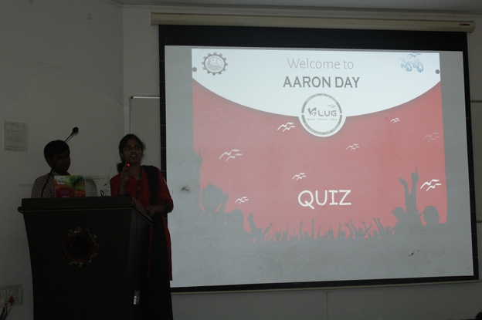

Webinar – Intro to Open Access
Mr Sridhar Gutam from Open Access India have an “Intro to Open Access” followed by discussions and QnA from the teams all over.

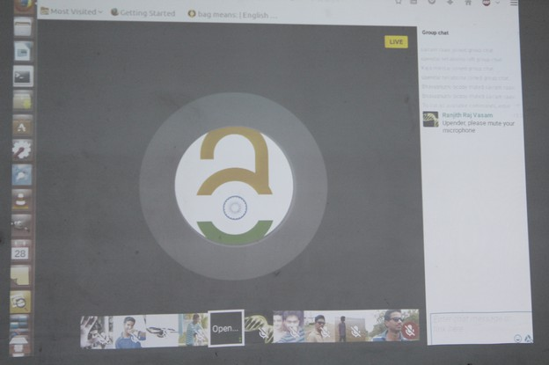

Debate - “Copyrights and Patents”
The participants had a progressive debate about the impact of copyrights and patents in the current society. Many important points came up in the discussion in support of copyrights and counter-arguments were posed. Few notable questions include
- What happens to the years of hardship of a developer if its given open
- Revolution of Polio vaccine which was not patented by Jonas and the steam engine which took long to develop as it was patented
- Cancer and AIDS drugs fighting for patents while thousands die in Africa
- What would be a students situation if Projects available online are copyrighted
- What would be the scenario without Wiki, Forums
- The developer loses his credit if its given open
- Whether safety and encryption are better off if they are OPEN or CLOSED
- OPEN Systems are vulnerable to Threat which was proved false by the argument where Worlds most servers and security systems run on FOSS

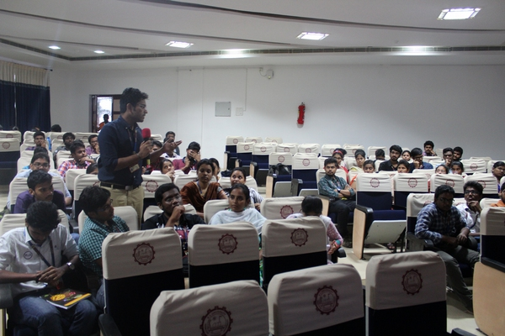
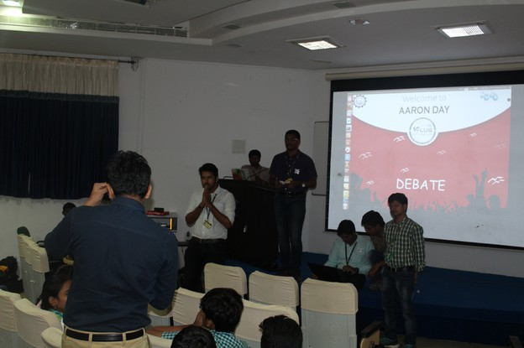

Talk- Mr Pramod, Swecha:
Mr Pramod gave a brief talk on the works of Aaron and the results of the actions he had taken. He discussed the importance of knowledge being open and accessable to everyone.
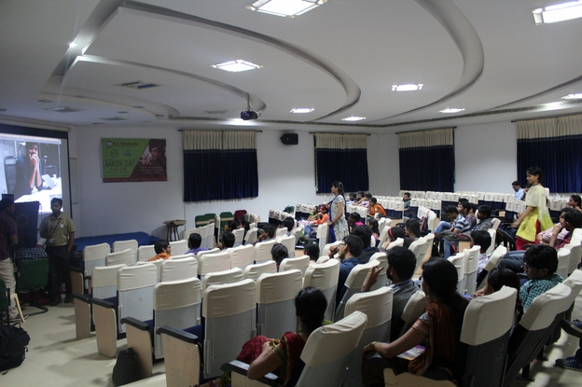

Screening - “Internet’s Own Boy – A story of Aaron Swartz” and Discussion:
The debate on Copyrights followed by talks on Open access and Knowledge forms and the documentary. Post Screening a brief discussion was made where the participants got a clear picture on the necessity of open knowledge systems and the clear stand against the Copyrights which they had earlier as a part of debate.




